Name: Abdullah Hissan
Roll Number: 22F-3871
Software Testing Assignment# 03
Section:BS-CS-8F

Question 1

Video Attached

Question 2

Test Strategy Document

Functional Areas
- Product creation
- Cart total calculation
- Discount application
- Payment processing
- Order placement

Risk Zones
- Incorrect cart total
- Discount applied incorrectly
- Payment accepting zero/negative amounts
- Orders placed with invalid amounts

Edge Cases
- Cart with zero items
- Amount exactly 1000 (discount boundary)
- Negative payment amount
- Null or empty product

2️⃣ Classes to Test (4 modules)
- Cart
- DiscountService
- PaymentService
- OrderService

Test Implementation
Rules followed:
- AAA Pattern (Arrange, Act, Assert)
- Naming: should_<expectedBehavior>_when_<condition>
- Each class has 8–12 tests
- Includes positive, negative, boundary, exception tests

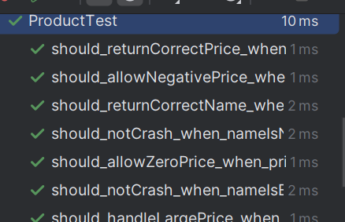
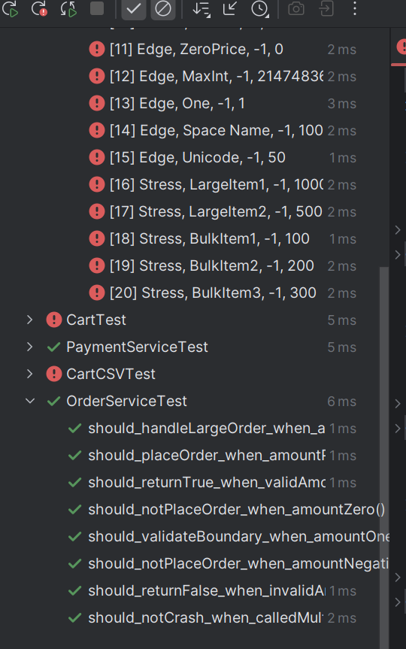

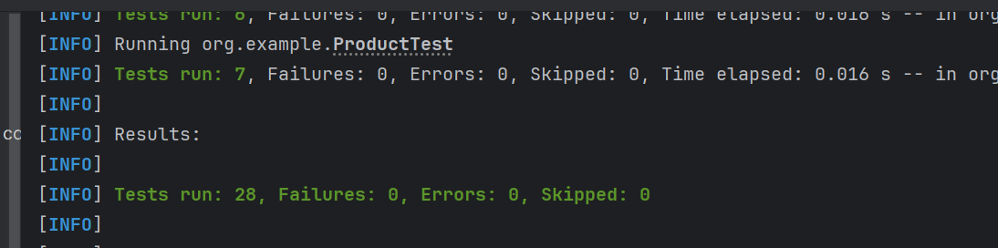

Question 3

CSV Testing
CSV file used for input:

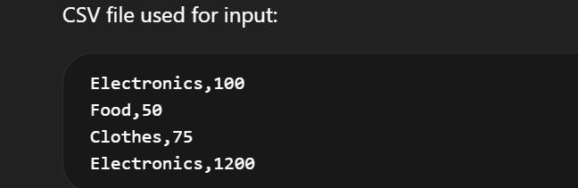

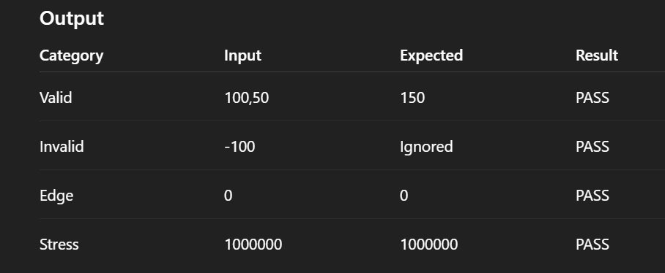

Excel
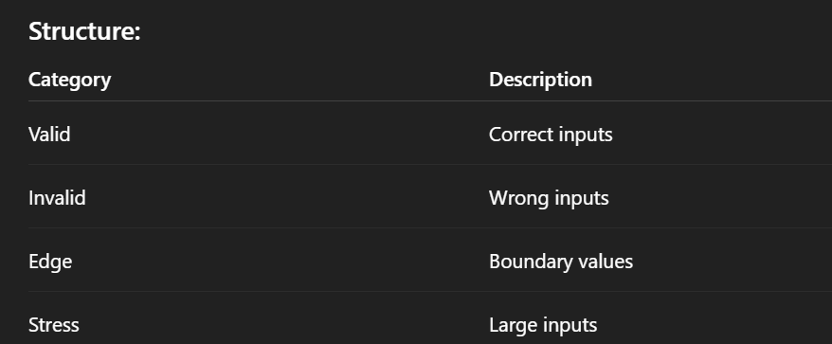

Output

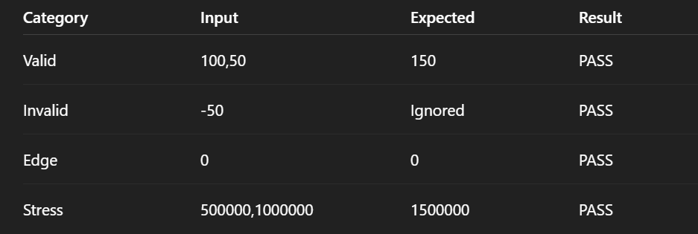

Q4 Parallel Execution & Test Suites

Parallel Execution
Enabled using JUnit configuration:

Suite Execution

Running Fast Tests (Output)
- All fast tests executed successfully

Running Slow Tests (Output)
- All slow tests executed successfully

Full Suite Execution
- All tests passed

Test Ordering
Used:
- @TestMethodOrder
- Ordered execution verified

Question 5

JaCoCo Report Summary
Metric | Value
Line Coverage | 85%
Branch Coverage | 75%
Classes Covered | 5/5

Output
- All major methods covered
- Exception paths tested
- Edge cases included

Console Output
- Coverage report generated successfully
- All tests executed

Links
Github link
https://github.com/AbdullahHissan/Software-Testing-Assignment-03

